# **1. Maximise DM Demo Access**

1. Open a putty session and enter the hostname as **10.0.1.30** Port **22**

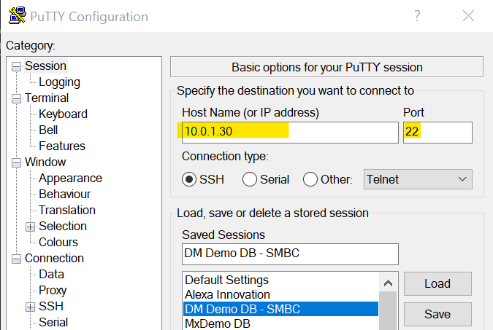

1. Navigate: Category > Connection > SSH > Auth
   1. Point to the directory where the private key is saved (vision.ppk)
2. Navigate: Category > Connection > SSH > Tunnels
   1. Source Port = 1521
   2. Destination = localhost:1521
   3. Click on Add

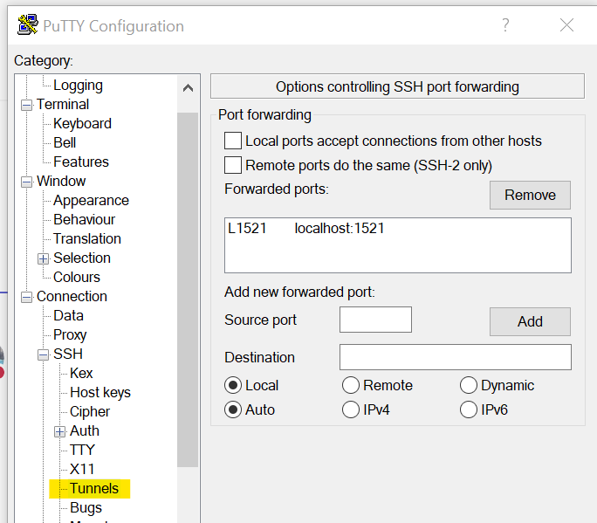

1. Navigate to **Session** under Category and name this connection (in the Saved Sessions field) and click on **Save** to save the connection
2. Click on **Open** to start a new session and login as user **opc**

# **2. SQL Developer Access – Maximise Pluggable Database 3**

**Create Jump Host and Local Port Forward to the Database**

1. Open a putty session and connect to the jump host (cwv1erpociproxy1.v1.com)
2. Enter credentials (windows username and password) and leave it running in the background
3. Open SQL Developer
4. Menu: View > SSH
5. Under the SSH Hosts dock, create a new SSH Host connection
6. Enter the name, host and username as below
7. Check the **Use key file** checkbox and point to the location where the mxdm3_ssh_key.ppk is downloaded

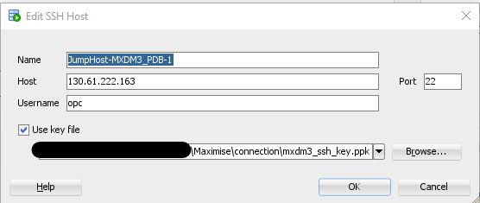

1. Click on **Ok**
2. Right-click on the new jump host name and create a **New Local Port Forward** connection
3. Enter the details as below:

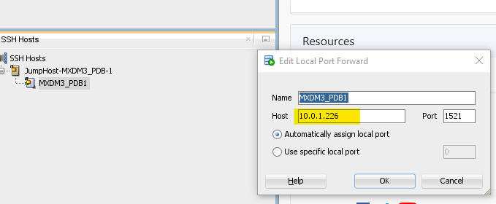

1. Click on **Ok**
2. Test the connection by right-clicking on the new jump host and select the Test Connection
3. If it successful, select the Connect option
4. Right-click on the local port forward connection and select the Connect option

**Create New DB Connection**

1. Under Oracle Connections, create a new db connection
2. Create a connection the XXMX_CORE, XXMX_STG and XXMX_XFM schemas as shown below:

Ensure that the Connection Type is SSH and the Port Forward is the same connection as set up above

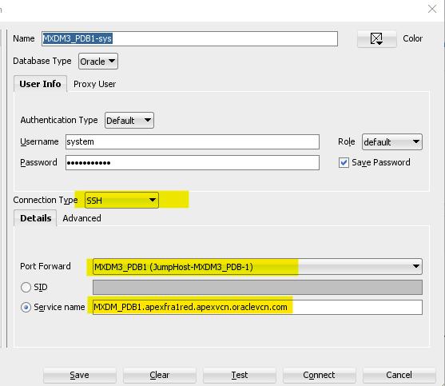

1. Hit the Test button to test the connection and successful save the connection
2. Repeat the steps 1-3 for the XXMX_STG and XXMX_XFM schemas